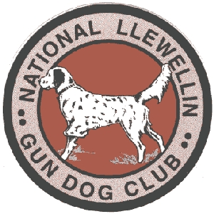
National Llewellin Gun Dog Club
2024 “MidWinter” Kentucky Field Trial
February 24.2024 starting at daylight
Sponsored by Sinking Fork Kennel, Hopkinsville Kentucky
Absolutely NO alcoholic beverages allowed at Sinking Fork Trial Grounds

DON’T forget to renew your membership at www.llewellinsetterclub.com
SEND ENTRIES PAYABLE TO TIM POWELL at P.O. Box 67, Gracey, Kentucky 42232

Physical address of Sinking Fork Trial Grounds is at 721 Shepherd Rd, Hopkinsville Ky 42240.

Registered Name of Dog: _____________________________ Call Name: ____________ Color: ________________
*Entries restricted to FDSB registered Llewellins Male _____ Female ______
Date whelped: ____________ FDSB #: _________________ (please include photocopy of registration certificate)
Sire: ______________________ Dam: _________________________
Handler: ______________________________________

Owner: ___________________________________________ Phone #: __________________________
Address: ________________________ City: __________ State: _____ Zip: _______
Email Address: _____________________________ ________________________________________

Birds used will be Quail

Number of Entries
____OPEN Saturday (no age restrictions) 30 minutes - $50.00 Total $ _______
____DERBY Saturday (under age 2 on day one of the 2023 trial season. March 1, 2023) 30 minutes - $50.00 Total $_______
____PUPPY Saturday (age 1 or under the day of the trial) 20 minutes - $35.00 Total $________
____OPEN Restricted Saturday (no age restrictions. No previous trial placements.) 30 minutes - $40.00 Total $_______
____OPEN Sunday (no age restrictions) 30 minutes - $50.00 Total $_______
____DERBY Sunday (under age 2 on day one of the 2023 trial season. March 1, 2023) 30 minutes - $50.00 Total $________
____OPEN Restricted Sunday (no age restrictions. No previous trial placements.) 30 minutes $40.00 Total $_______

Grand Total $_______________

Send Entries to: Tim Powell - P.O. Box 67 Gracey, KY 42232
Telephone: (270)348-4488 or (270)719-0932 or (270)887-9964
cxpsetter@me.com
Entries close Monday February 17,2024 at 7:00 pm EST.
Drawing Live on NLGDC Facebook page Tuesday February 20,2024 at 8 pm EST.

