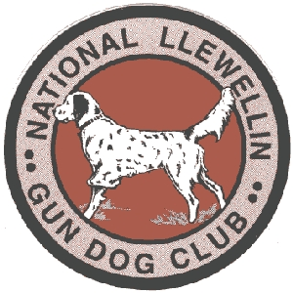
National Llewellin Gun Dog Club
February 2024 “MidWinter” Kentucky Field Trial

February 24-25, 2024
Entries restricted to FDSB registered Llewellins
Sponsored by: Sinking Fork Kennels

Chairman: Tim Powell

More details will be on the NLGDC website

Held in Hopkinsville, Ky. @ Sinking Fork Field Trial Grounds located at 721 Shepherd Rd, Hopkinsville Ky 42240

***IMPORTANT***

ENTRY FORMS: Please submit checks for trial to Tim Powell no later than Feb 17,2024.
Send Entries to: Tim Powell - P.O. Box 67 Gracey, KY 42232
Telephone: (270)348-4488 or (270)719-0932 or (270)887-9964
cxpsetter@me.com
Entries close Saturday February 17 at 7:00 pm EST.

