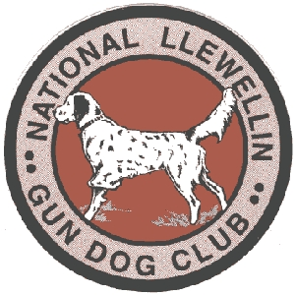
National Llewellin Gun Dog Club
BLUEGRASS BASH
March 12, 2017 starting at daylight
Sponsored by Sinking Fork Kennel, Butler Acres, On Point Kennels, Victor Dog Food, Moore's Hunting Preserve
DON’T forget to renew your membership at www.llewellinsetterclub.com
SEND ENTRIES PAYABLE TO TIM OR CRYSTAL POWELL at P.O. Box 67, Gracey, Kentucky 42232

Registered Name of Dog: _____________________________ Call Name: ____________ Color: ________________
*Entries restricted to FDSB registered Llewellins Male _____ Female ______
Date whelped: ____________ FDSB #: _________________ (please include photocopy of registration certificate)
Sire: ________________________________ Dam: _____________________________________
Handler: ______________________________________

Owner: ___________________________________________ Phone #: __________________________
Address: ________________________________ City: ________________ State: _____ Zip: _______
Email Address: _____________________________________________

Birds used will be Quail
Grounds available for training on Friday call to prearrange 270-348-4488
_________OPEN (no age restrictions) 30 minutes - $50.00 _______

_________DERBY (under age 2 on day one of trial season: March 12, 2017) 30 minutes - $50.00 _______

_________PUPPY (under age 1 on day one of trial season: March 12, 2017) 20 minutes - $30.00 _______
Send Entries to: Crystal Powell - P.O. Box 67 Gracey, KY 42232
Telephone: (270)348-4488 or (270)719-0932 or (270)887-9964
cxpsetter@me.com
Entries close Wednesday, March 8, 2017 at 7:00 pm
Hotel info: Kentucky Dam Village State Resort Park (270)362-4276

