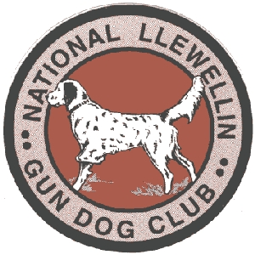
National Llewellin Gun Dog Club
March Trial and Annual Meeting

March 4 and 5, 2023
with Annual Membership Meeting will be held the evening of March 3, 2023 at
(location to be determined within the next week)
Entries restricted to FDSB registered Llewellins
Sponsored by: National Llewellin Gun Dog Club

Chairman: Tim Powell
Secretary: Jon Bronnenberg

More details will be on the NLGDC website

Held in Hopkinsville, Ky. @ Sinking Fork Field Trial Grounds located at 721 Shepherd Rd, Hopkinsville Ky 42240

***IMPORTANT***

ENTRY FORMS: Please submit checks for trial to Tim Powell no later than February 24,2023.
Send Entries to: Tim Powell - P.O. Box 67 Gracey, KY 42232
Telephone: (270)348-4488 or (270)719-0932 or (270)887-9964
cxpsetter@me.com
Entries close Monday February 24,2023 at 7:00 pm EST.

