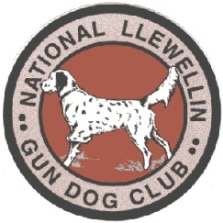
National Llewellin Gun Dog Club

***Announcing a New Llewellin Trial***

THE NLGDC INDIANA CLASSIC

October 29th and 30th, 2022 at Pike County Bird Hunters Club
575 South 325 West Petersburg, IN. 47567

Sponsored by River View Kennels and Pride Llewellin Kennels

You must be a paid member to enter your dogs. Renew your membership at www.llewellinsetterclub.com

We will have the following classes on Saturday 10/29/22
Open, Derby, Puppy, and Open Restricted

Classes on Sunday 10/30/22
Open, Derby, and Open Restricted

Pike Club Rules state Absolutely NO alcoholic beverages allowed on Pike Club Grounds

Birds used will be Quail

You may exercise your dogs in the field on Friday but will not be allowed to plant or work with any live birds.

Please contact Jon Bronnenberg at 260-358-7277 (text or call) or jonbron@citznet.com as soon as possible and let me know if you will be able to attend.

Hotel information to be supplied at a later date.

We hope to see all of you there!

