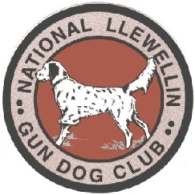
National Llewellin Gun Dog Club

Hotel Accommodations Nearby For

THE NLGDC INDIANA CLASSIC

October 29th and 30th, 2022 at Pike County Bird Hunters Club
575 South 325 West Petersburg, IN. 47567

- Logs End Bed and Breakfast, Petersburg, In. PH. 812-354-2192
- Holiday Inn Express, Washington, In. PH. 812-254-6666
- Budget Inn, Washington, IN. PH. 812-254-5816
- Baymont by Wyndham, Washington, IN. PH. 812-254-7000
- Theroff’s Motel, Washington IN. PH. 812-254-4279
- Diplomat Motel, Oakland City IN. PH. 812-749-4300
- Comfort Inn, East Evansville, IN. PH. 812-476-3600
- Fairfield Inn by Marriott, East Evansville IN. PH. 812-471-4000
- Baymont by Wyndham, East Evansville IN. PH. 812-477-2677
10. Country Inn and Suites, East Evansville IN. PH. 473-2500
11. LaQuinta Inn and Suites, East Evansville IN. PH. 812-471-3414
12. Hampton Inn, East Evansville IN. PH. 812-473-5000
13. Courtyard by Marriott, East Evansville IN. PH. 812-424-4242
14. Holiday Inn Express, East Evansville IN. PH. 812-303-0050
15. Residence Inn, East Evansville IN. PH. 812-471-7191
There are numerous other places in Evansville to stay as well.

Please contact Jon Bronnenberg at 260-358-7277 (text or call) or jonbron@citznet.com as soon as possible and let me know if you will be able to attend.

We hope everyone can make it!

