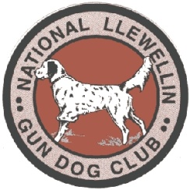
NATIONAL LLEWELLIN GUN DOG CLUB FIELD TRIAL,

March 16 & March 17 starting at 8:00 am

DON’T forget to renew your membership too at www.llewellinsetterclub.com or send checks payable to NLGDC, c/o Caren Mansfield, P.O. Box 265, Mechanicsburg, Illinois 62545

Registered Name of Dog: _____________________________ Call Name: ____________ Color: ________________
*Entries restricted to FDSB registered Llewellins Male _____ Female ______
Date whelped: ____________ FDSB #: _________________ (please include photocopy of registration certificate)
Sire: ________________________________ Dam: _____________________________________
Handler: ______________________________________

Owner: ___________________________________________ Phone #: __________________________
Address: ________________________________ City: ________________ State: _____ Zip: _______
Email Address: _____________________________________________

Birds used will be Quail
SATURDAY: OPEN (no age restrictions) 30 minutes - $50.00 ________________________
SATURDAY: DERBY (under age 2 on day one of trial season- March 4, 2023) 30 minutes - $50.00 __________
SATURDAY: RESTRICTED (Never placed 1st-3rd in Open or Derby, can’t run in those same day) - $40 ___________

SUNDAY: OPEN (no age restrictions) 30 minutes - $50.00 ________________________
SUNDAY: DERBY (under age 2 on day one of trial season- March 4, 2023) 30 minutes - $50.00 __________

Send Entries to: Colin Fowler, 2610 Brand Rd, Cable, OH 43009
Colin Fowler: (937) 631-0258, ckfowler180@gmail.com
ENTRIES MUST BE RECEIVED BY Tues March 12, 2024 7:00pm

